CS624 Full-Stack Development Mobile App

**PE01 – Hello World**

Developed by Sam Chung on February 25, 2022

School of Technology & Computing (STC)

City University of Seattle (CityU)

**Before You Start**

* You already created a private GitHub repository for all your programming exercises, “cs624-pe-your_first_name.”
* You allowed your instructor and the Teaching Assistant to access your GitHub repository for programming assignments.
* The GitHub Codespaces may bill your account according to your usage. Check the price at <https://docs.github.com/en/billing/managing-billing-for-github-codespaces/about-billing-for-github-codespaces>. Please pay attention to the storage and core hours of use free of charge for personal accounts.
* Some steps are not explained in the assignment**.**If you are not sure what to do:
  + Consult the resources listed in your course.
  + If you need help solving the problem after a few tries (~15 minutes), ask a TA for help.

**Learning Outcomes**

Students will be able to:

* + Create a React Native mobile app using Codespaces, Expo, and Reactive Native.

**Problem**

Write a “HelloWorld” mobile app that will display your name, degree program, and school with the following constraints:

* User Requirements
  + Text messages in a yellow background color. The text messages show
* System Requirements
  + You can use a total of five React Native components (1 View, 3 Text, and StyleSheet).

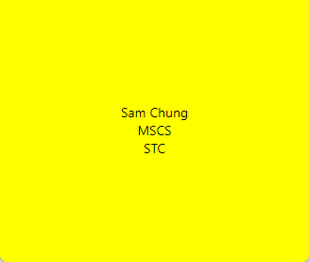

**Submission**

1. Create a GitHub repository for your programming exercises. The repository name will be “cs624-pe-*your_first_name*.”

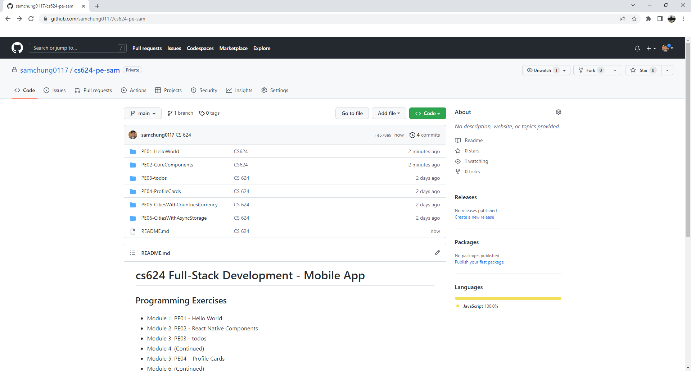

1

1. Click the Settings menu. Invite your instructor and TA to collaborators.

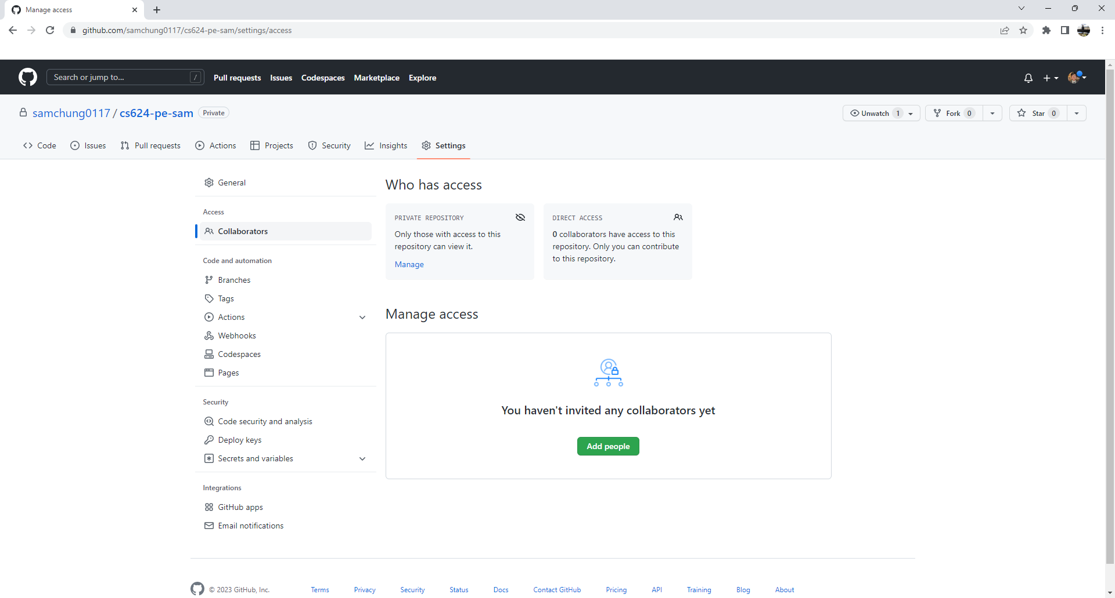

1

1. Under the repository, create a directory for the programming exercise 1, “PE01-HelloWorld.” For example, the screen below shows that the following seven directories were created for all programming exercises.



1. Finish your programming exercise under the PE01 directory.
2. Write a 150-word analysis report to explain how the program works in [README.md](https://www.markdownguide.org/basic-syntax/) in terms of the [input-process-output model](https://press.rebus.community/programmingfundamentals/chapter/input-process-output-model/). The README.md has three level-1 headings – Input, Process, and Output.
3. Submit the link of your GitHub repository to your course shell through your assignment submission.

